**CSE3004 Design and Analysis of Algorithms ELA Winter 2023-2024 Semester**

**Lab sheet - (L15+L16)**

**Name :** Koya Madhusudhana Rao

**Reg.No :** 21BCE9905

Git Hub Repository :- <https://github.com/Koya-Madhusudhana-Rao/DAA-Lab>

1. Write a programs to implement the following:

(a) Quick Sort

*//import java.util.Scanner;*

**public** **class** quicksort {

**public** **static** **void** main(String args[]) {

*//Scanner sc = new Scanner(System.in);*

**int** arr[] = { 1, 2, 3, 8, 7, 6, 4 };

**int** l = 0;

**int** r = arr.length;

*// Before Sorting of arrya*

        System.out.println("Before sorting");

        for (**int** n : arr) {

            System.out.print(n + " ");

        }

*// Performing quicksort*

        quicksorte(arr, 0, arr.length - 1);

*// after sorting*

        System.out.println("");

        System.out.println("After sorting");

        for (**int** n : arr) {

            System.out.print(n + " ");

        }

    }

*// Method to qucksort recursively*

**public** **static** **void** quicksorte(**int**[] arr, **int** l, **int** r) {

        if (l < r) {

**int** pi = partition(arr, l, r);

            quicksorte(arr, l, pi - 1);

            quicksorte(arr, pi + 1, r);

        }

    }

*// method for finding pivot element and swaping with left most element if it was*

*// low*

**public** **static** **int** partition(**int**[] arr, **int** l, **int** r) {

**int** pivot = arr[r];

**int** i = (l - 1);

        for (**int** j = l; j <= r - 1; j++) {

*// If current element is smaller than the pivot*

            if (arr[j] < pivot) {

*// Increment index of smaller element*

                i++;

                swap(arr, i, j);

            }

        }

        swap(arr, i + 1, r);

        return (i + 1);

    }

*// Performing swaping*

**public** **static** **void** swap(**int**[] arr, **int** i, **int** j) {

**int** temp = arr[i];

        arr[i] = arr[j];

        arr[j] = temp;

    }

}

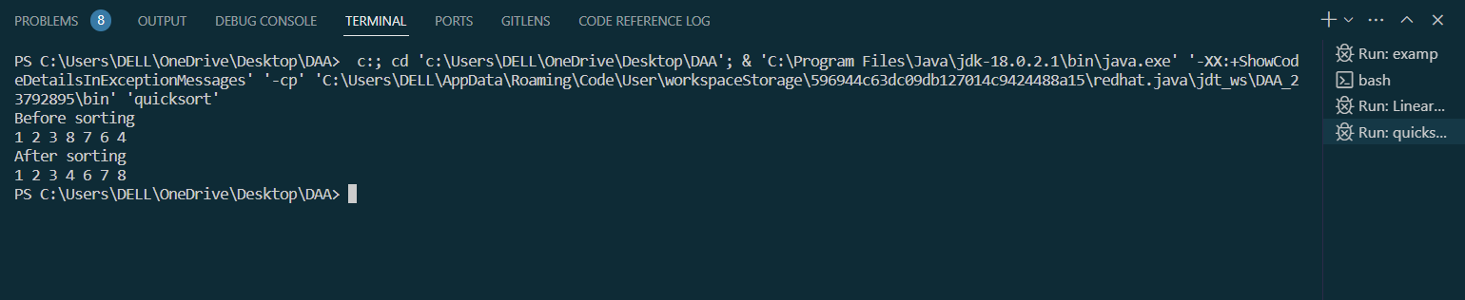

(b) Merge Sort

**public** **class** mergesort {

**public** **static** **void** main(String[] args) {

**int** arr[] = { 2, 5, 1, 3, 4, 7, 8, 9, 6 };

*// Before Sorting of Array*

        System.out.println("Befor Sorting");

        for (**int** n : arr) {

            System.out.print(n + " ");

        }

*// performing Merge sort*

        mergesort(arr, 0, arr.length - 1);

        System.out.println("");

        System.out.println("After Sorting");

        for (**int** n : arr) {

            System.out.print(n + " ");

        }

    }

*// Method for dividing array*

**public** **static** **void** mergesort(**int**[] arr, **int** l, **int** r)

    {

        if (l < r) {

**int** mid = (l + r) / 2;

            mergesort(arr, l, mid);

            mergesort(arr, mid + 1, r);

            merge(arr, l, mid, r);

        }

    }

*// Actually merging elements*

**public** **static** **void** merge(**int**[] arr, **int** l, **int** m, **int** r)

    {

**int** n1 = m + 1 - l;

**int** n2 = r - m;

**int**[] larr = new **int**[n1];

**int**[] rarr = new **int**[n2];

        for (**int** x = 0; x < n1; x++) {

            larr[x] = arr[l + x];

        }

        for (**int** x = 0; x < n2; x++) {

            rarr[x] = arr[m + 1 + x];

        }

**int** i = 0, j = 0, k = l;

        while (i < n1 && j < n2) {

            if (larr[i] <= rarr[j]) {

                arr[k] = larr[i];

                i++;

            } else {

                arr[k] = rarr[j];

                j++;

            }

            k++;

        }

        while (i < n1) {

            arr[k] = larr[i];

            i++;

            k++;

        }

        while (j < n2) {

            arr[k] = rarr[j];

            j++;

            k++;

        }

    }

}

